Diving PAM II
Basic Operation and Protocol

PAM Overview
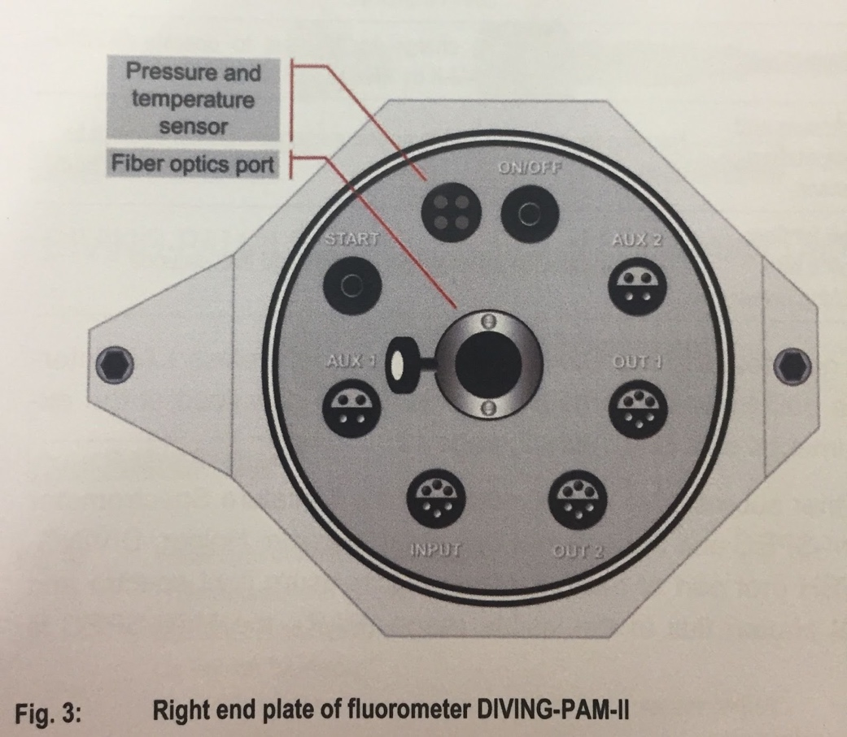
- AUX1/AUX2 connects to Mini Spec or Fiber Optic Oxygen Meter FireSting O2 (← THIS IS AMAZING)
- Fiber Optics Port: Where the fiber optics cable is inserted into the main console.
- INPUT: Interface to charge the battery and to operate the Diving PAM via WinControl-3
  - As a note, this protocol as it stands will not cover operating DIVING PAM with WinControl. This protocol is meant to be optimized for in situ measurements

Connecting the Fiber Optic Cord to the PAM: Ensure it is snugly in its port and tighten screw accordingly. There should be no wiggle or play.
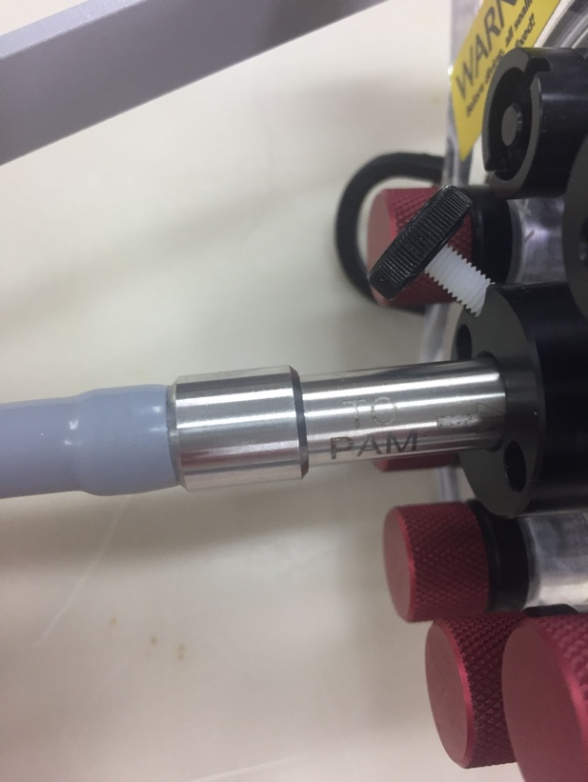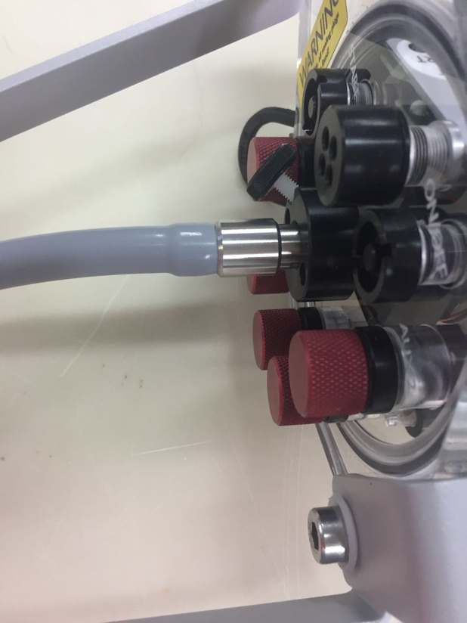

Setup for Leafy Material: Seagrasses, Algae, Kelp
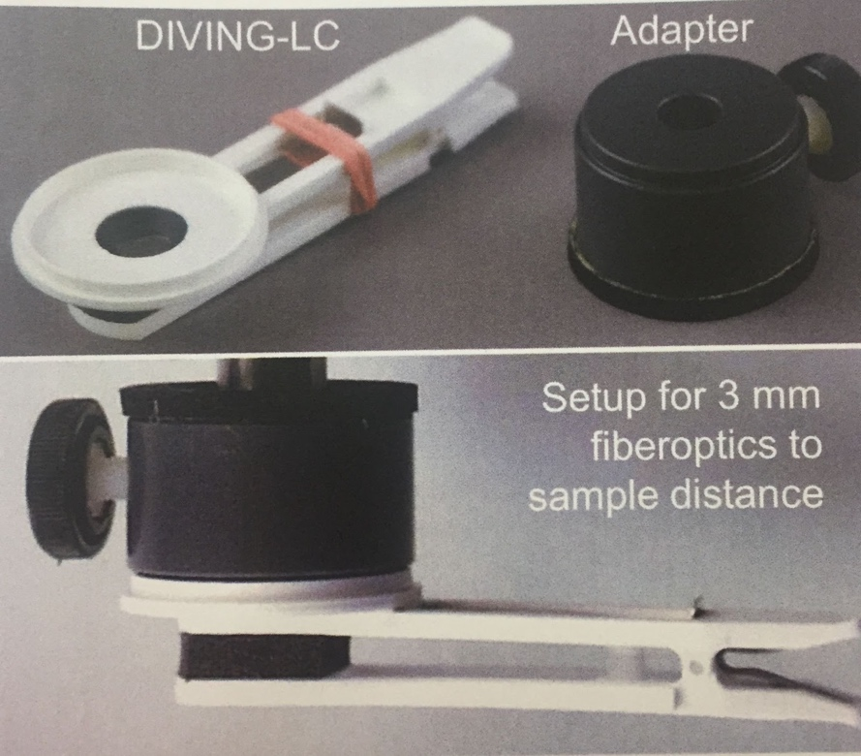
Setup for Coral including diagrams for achieving optimal distance.
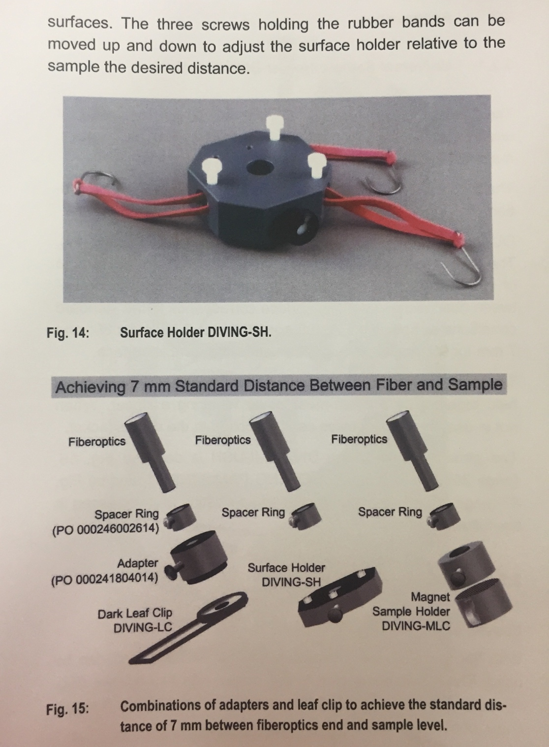

Additional Image of Coral Surface Holder with Dark Adaption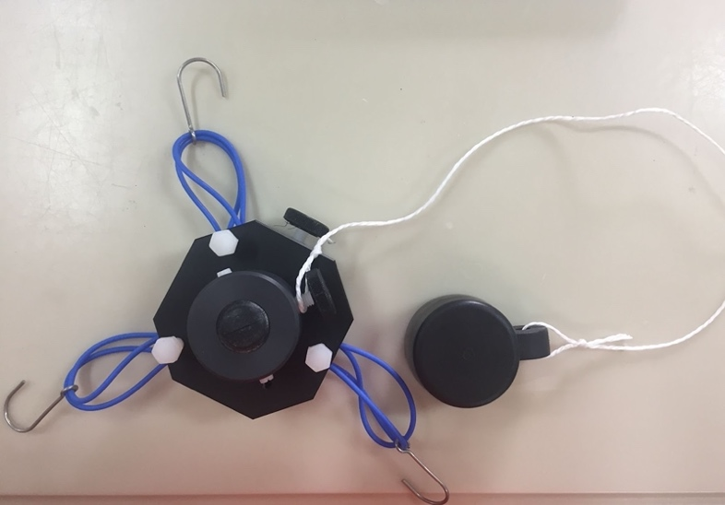
*Note the adaptor is placed directly over the surface holder. There is a slit in the black plug for the fiber optic cord to go through. The black plug attached to the string is buoyant and magnetic. It is meant for ease of use.
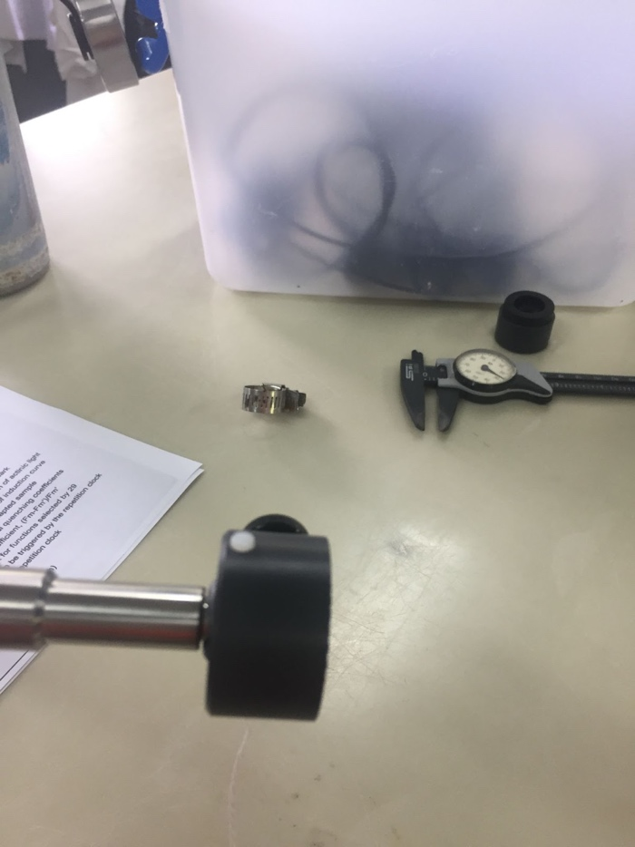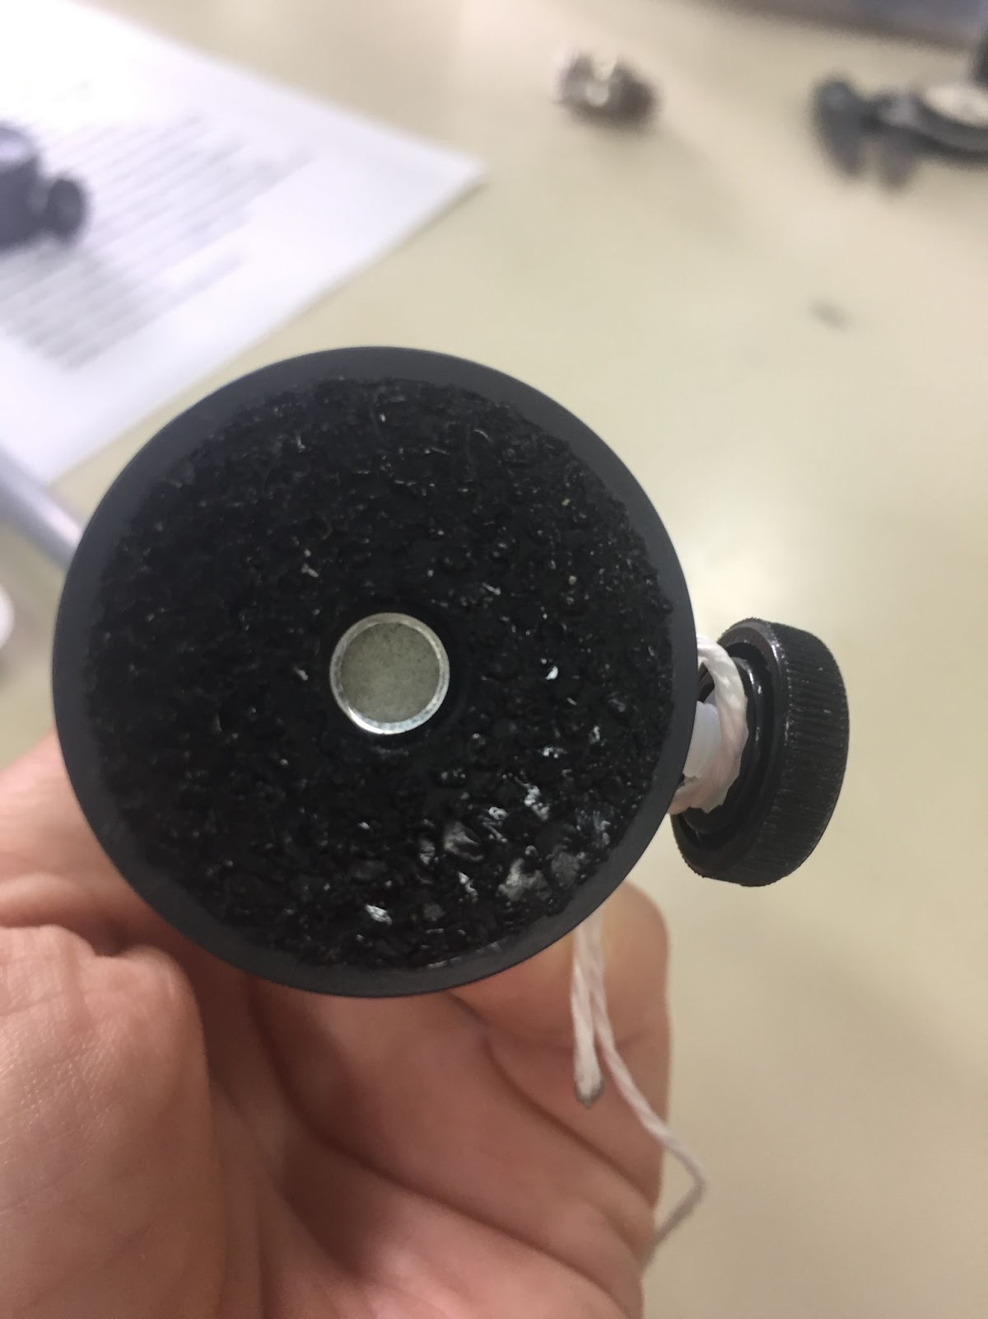
Image of fiberoptics inserted into the Adaptor.

Getting the PAM Ready to Rumble
- Unless you are using the MINI-Spec, make sure the PAR is selected for internal PAR sensor. Select Menu ⇒ Sensors ⇒ Use Int. PAR ⇒ On Basic Data Page, select Act.L.
- Adjust GAIN: This is the first of three parameters used to optimize your signal:noise ratio. Noise increases with increasing signal amplification. *Note, Gain should be optimized to your weakest signal (i.e. your most stressed animal).
  - Gain is adjusted by referencing your Ft value (i.e. your current fluorescence)
  - When adjusting Gain, you want your Ft value to be within range of 300-500
  - To adjust GAIN: Select Menu ⇒ PAM Settings ⇒ Gain ⇒ Select and adjust values between 1-4.
- Adjust DAMPING: Damping suppresses High Frequency Noise. This ranges from 0-20. The higher your damping, the longer your response time.
  - Adjusting DAMP vs.GAIN requires play. You will have to optimize this to the values you think are most appropriate for your organism.
- Final range of Ft should be between 300-500. Make sure you record your Gain and Damp. This is oftentimes required to publish. Also, once these values are SET, you cannot change them for the duration of your experiment and data collection period.
- Adjust F-Offset: This determines the background signal for the subtraction from the total signal.
  - You MUST F-offset after every change to DAMP and GAIN. You must also adjust F-Offset before EVERY data recording period. This should be done in as close to experimental/field conditions as possible. Ideally, this should be done using experimental treatment or on DIVE in the field.
  - Best practice is to ZERO PAM, using a leaf clamp with the metal slider closed.
  - Select Menu ⇒ PAM Settings ⇒ Adjust F-Offset
    - It will run for 30s
    - Ft should drop to ~0. Likely between 0-20 with clip on
PAM SETTINGS FOR DIFFERENT CORAL SPECIES
SPECIES | GAIN | DAMPING | LIGHT SAT | SPACE (mm)
Agaricia spp. | 2 | 1 | 10 | 7
Acropora cervicornis | 1 | 1 | 10 | 7
Diploria labyrinthisformis | 3 | 1 | 10 | 7
Siderastrea siderea | 1 | 1 | 10 | 7
Porites porites | 1 | 1 | 10 | 7
Montastrea cavernosa | 2 | 1 | 10 | 7
Orbicella faveolata | 1 | 1 | 8 | 7

Taking Measurements

Fv/Fm
- Before taking measurements, the organisms should be in its natural experimental condition (light, temp, etc) for a minimum of 24 hours. This is because you want all active photosystems active. Dark Adaptation should last for 20 mins, so the photosystems are most relaxed.
- Select F2. Fv/Fm will show on the main panel.
- Cross validate your values with reported values in the literature.
- Temperature and PAR are the two most important drivers for photosynthesis. In order to make direct comparisons, conditions must be the same or as similar as possible.

Rapid Light Curves
- Again, this requires some play and a defined expectation for outcome. Literature searches are critical to determine the duration of the light curve.
- RLC should start at a PAR value below that of its natural environment. They should be acclimated to experimental conditions and NOT dark adapted.
- If the illumination steps are long enough and refined enough to reach photosynthetic steady state (the asymptote), you can use them as classical light response curves. This means you can calculate alpha, rETRMAX , Ek with considerable confidence.

References
Tunala, Layla Poubel, Frederico T.S. Tâmega, Heitor M. Duarte, and Ricardo Coutinho. 2019. Stress Factors in the Photobiology of the Reef Coral Siderastrea Stellata. Journal of Experimental Marine Biology and Ecology. 519: 151188. https://doi.org/10.1016/j.jembe.2019.151188.
-- 0.733 and 0.734 for LL and 0.694 and 0.704 for HL
Manzello, D., M. Warner, E. Stabenau, J. Hendee, M. Lesser, and M. Jankulak. 2009. Remote Monitoring of Chlorophyll Fluorescence in Two Reef Corals during the 2005 Bleaching Event at Lee Stocking Island, Bahamas. Coral Reefs 28 (1): 209–14. https://doi.org/10.1007/s00338-008-0455-7.
-- Fv/Fm values 0.45-.65
Cunning, Ross, Rachel N. Silverstein, and Andrew C. Baker. 2018. Symbiont Shuffling Linked to Differential Photochemical Dynamics of Symbiodinium in Three Caribbean Reef Corals. Coral Reefs 37 (1): 145–52. https://doi.org/10.1007/s00338-017-1640-3.
‘
Finelli, C. M., B. S. Helmuth, N. D. Pentcheff, and D. S. Wethey. 2007. Intracolony Variability in Photosynthesis by Corals Is Affected by Water Flow: Role of Oxygen Flux. Marine Ecology Progress Series 349: 103–10. https://doi.org/10.3354/meps07101.

https://aquation.com.au/white-papers/a-guide-to-analyzing-rapid-light-curves/

Additional Information
Below are commands from earlier models of the PAM. This might be helpful as a reference when you are trying to troubleshoot. Printed copies are also available in the PAM case.
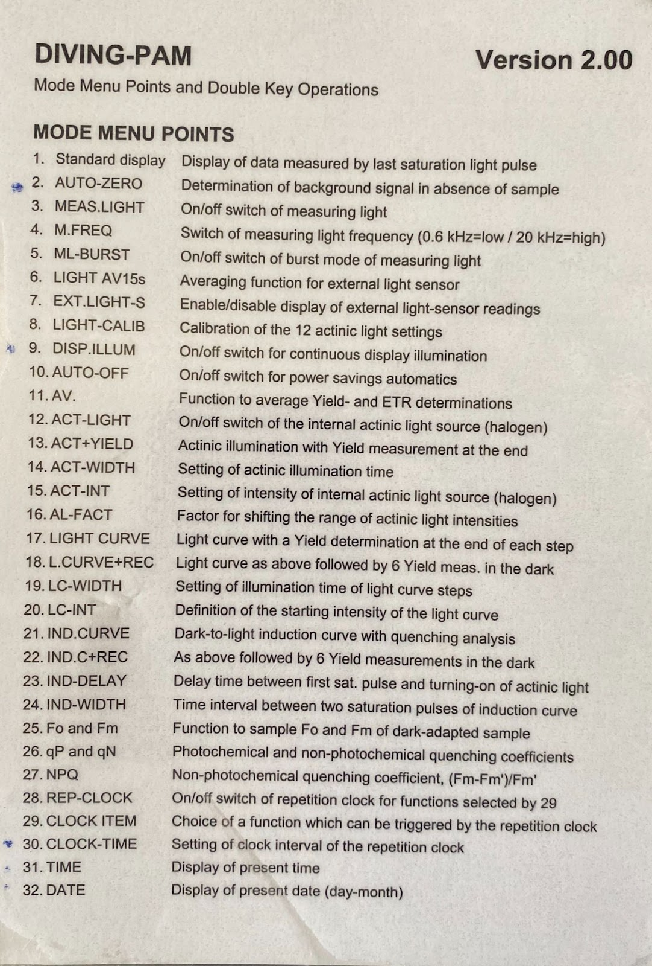
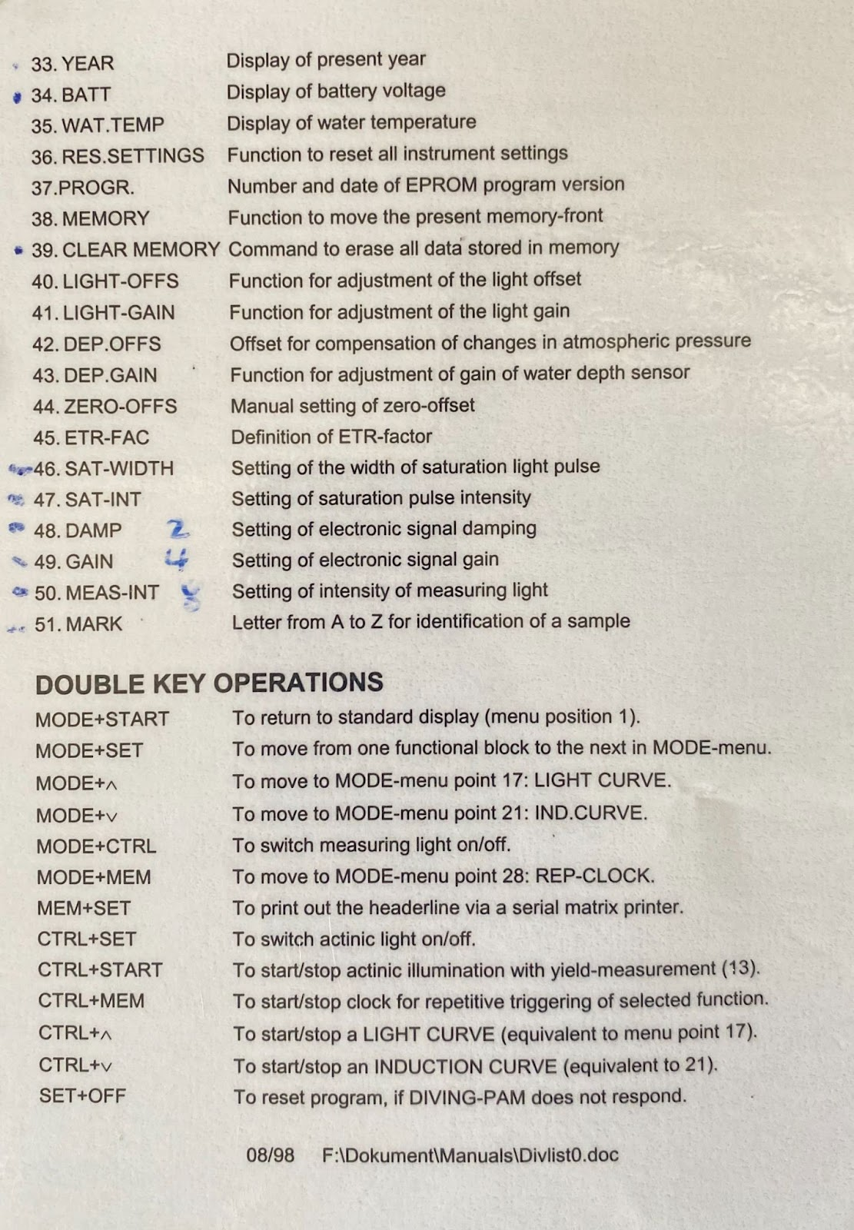

Field protocol for operating DIVING PAM version 05Nov2021

Brief protocol for field work:
- Attach fiber optic cable
- Attach mini-spec to AUX1 or AUX2 (mini spec is the light meter that is black cylinder with small cylindrical tip)
- Make sure all ports are occupied by cable or plug
- Remove cap from minispec (this is small cap over the sensor itself which is small white circle in tip with faded pink tape wrapped around it. Do not lose the cap!)
- The following steps are underwater:
- Adjust F-offset (aka “Auto-zero”)
  - Choose dim environment (i.e., environment where PAMing will be done)
  - Point fiber tip away from surface or bottom (i.e., straight into water column parallel to bottom). Do not point up towards sunlight or down towards fluorescing organisms.
  - Run “Adjust F-Offset by (hit “set” to select something that I highlighted
    - ‘Main Menu’ -> PAM settings’ > Set-> “Adjust F-Offset” highlighted
    - You will be asked “Adjust F-Offset”?
    - Scroll down to highlight “yes”
    - Hit “Set/Menu” button
    - *This offset is for cancelling out fluorescing organisms in water. In water point out sideways. In lab, do so with thumb over donut.
  - Wait and watch 40 second countdown as F-Offset is adjusted
- Get initial “Ft” value to fall between 300-500 when pointing at a coral
  - Do this before starting a given species at a given site
  - Adjust Measuring Light Intensity (MLI) and Saturating Intensity (SI) values to get F value to 300-500. Sara typically starts with MLI and SI at value of 8.
  - To adjust MLI: ‘Main Menu’ -> ‘PAM Settings’ -> ‘Meas. Light Sett.’ -> ‘Meas. Light Int.’ > set > use up or down arrows to get desired value. RECORD VALUE AT TOP OF DATASHEET
  - To adjust SI: ‘Main Menu’ -> ‘Light sources’ -> ‘SAT Settings’ -> ‘SAT Intensity’ > set > use up or down arrows to get desired value. RECORD VALUE AT TOP OF DATASHEET
  - SAT Width (s) set at 0.8 second. Should probably stay at 0.8.
  - ETR has been left the same value of 0.84
- Before taking first reading, record “SI, G, D, F, SW, MLI” at top of data sheet
  - These stand for:
    - Saturation Intensity (set by us),
    - Gain (found on ‘Main Menu’ -> ‘PAM Settings’ screen),
    - Damp (found on ‘‘Main Menu’ -> PAM Settings’ screen),
    - Saturation width (‘Main Menu’ -> ‘Light sources’ -> ‘SAT Settings’ -> ‘SAT Width’
    - Measuring light intensity (set by us)
- To take reading:
  - Either a) pressing the side “START” trigger button when the “SAT” command is displayed in the top right corner of the current display or b) press the optical button “SAT START.”
  - Record on data sheet: Plot, Time, Mem, F (in place of F0), Y(II) (in place of ETR)
    - ‘Mem’ is just a running number of that we use as index. Start with 1 for first reading.

Other notes:
- Actinic light stays off
- To get recorded data:
  - Main menu > memory > data sets
  - This will give indication of number of stored data sets
- To download data:
  - Need PC
  - Need download app (Wincontrol)
  - Download data into app
  - Save it then to a .pam file
  - Open .pam file with excel
  - Column headings don’t necessary download, so need to manually transfer over based on the app.
  - Data output Y(II), F, others could be useful as well.

